Shift Offers-Analysis

Prepared for: Clipboard Health Executive Team

Prepared by: Sindhu Thapa

Date:13/03/2025

- Executive Summary
Clipboard Health is a two-sided marketplace where healthcare workers claim per diem shifts that workplaces post. This platform’s success relies on shift fulfillment rates, worker engagement, and reasonable pricing strategies to increase revenue and decrease unfilled shifts.

This report offers key findings from analyzing marketplace transaction data and provides revenue growth strategies:
- Shift Claims & Revenue Maximation: Pay Rate Optimization
- Dynamic Pricing Strategies Based on Demand & Shift Slots: This model uses the price of the shift and the time of day to set the rate, resulting in higher pay for peak hours and lower pay for slower periods.
- Staff Retention Tools: Sign-on bonuses, incentives, and performance-based bonuses to keep staff on the platform and reduce empty miles.
- Reducing No Call No Show (NCNS) Losses: Offer incentives for last-minute cancellations and use automated messaging to reduce the likelihood of missed shifts.
- Balancing Supply & Demand for Sustainable Growth: Maintain a steady supply during peak hours while avoiding oversupply during slower times.
- Market Trends & Findings
2.1. Pay Rate vs Claim Rate – Revenue Implications
Finding:
- Claim rates are rising, with pay rates up to $40/hr.
- Unemployment rates of $40-$50 per hour are relatively low as long as the tips or incentives are average.
- Beyond $40/hr, claim rates become volatile, and while the shifts remain unfilled with high pay, it could be attributed to how the rates are structured.
Revenue Opportunity:
- Maximize claims at minimum cost, cap most shifts at $40/hr, and optimize shift pricing.
- Surge pricing should only be used for shifts that don't fill at $40/hr.

Recommended Action Plan:
- Using AI technology to manage pricing and price change based on shift demand trends.
- Instead of simply raising the base pay, introduce tiered incentives (for example, $35/hr Base Pay + $5 bonus for shifts claimed within 3 hours. $38/hr Base Pay + Guaranteed next day payout to increase quicker worker commitment).

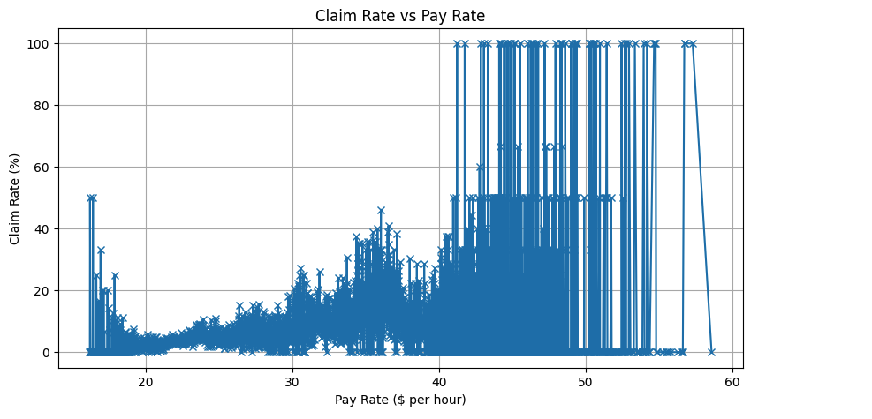
2.2. Shift Slot Analysis – Optimizing Worker Distribution
Findings:
- Night shifts have the highest claim rates (6%).
- They are more challenging to fill than AM & PM shifts (4.5%) because of lower claim rates.
Revenue Opportunity:
- Increase AM & PM shift fulfillment using strategic incentives instead of pay hikes.
- Reduce unclaimed shifts, which leads to revenue loss.
Recommended Action Plan:
Bundle Shifts: Increase your earnings when you book consecutive shifts (e.g., two PM shifts = $50 bonus).
- Dynamic Scheduling Discounts: Give preferential scheduling to workers likely to take AM/PM shifts.
- Workplace Subscriptions: Make facilities pay extra to guarantee assistance with shift fulfillment, especially during the AM & PM.
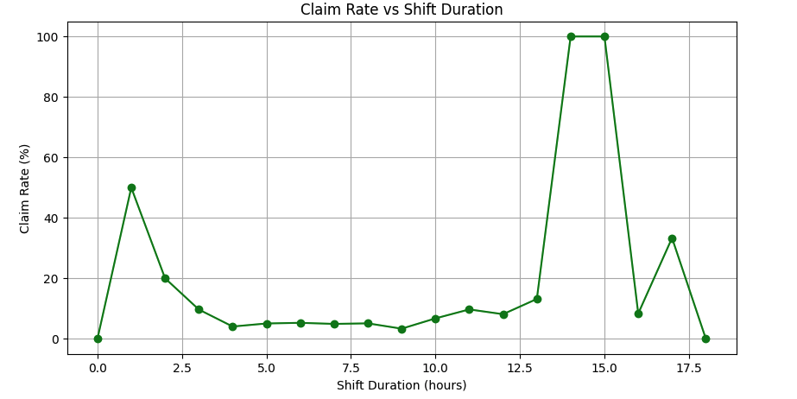

2.3. Hourly Demand Trends – The Best Time to Post Shifts
Findings:
- Shifts posted at 10 AM are filled immediately (nearly 100% claim rate).
- The other time slots have 5-20% claim rates.
Revenue Opportunity:
- Post high-priority shifts at peak times (10 AM) to maximize engagement.
- Charge facilities premium fees for shift posting slots are the most important.
Recommended Action Plan:
- Introduce “Prime Shift Posting” for Facilities – a charge for shift posting premium slots.
- Does exercise shift release strategies to see whether earlier or later postings enhance the claim?
- Notify workers of upcoming shifts by automated push notifications before the peak claim hours.
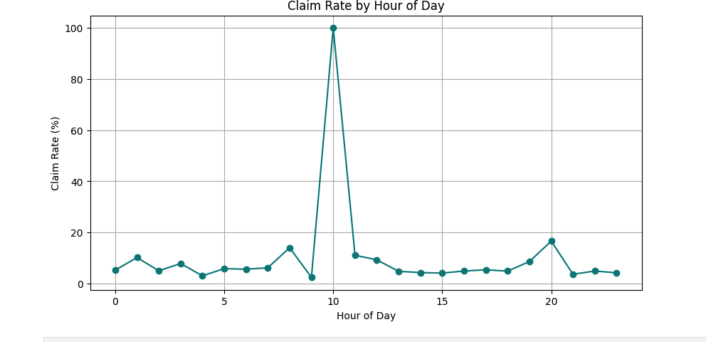
2.4. Weekly & Monthly Trends – The Use of Seasonal Workforce Planning.
Findings:
- Claim rates are constant (4.5%) for most of the year.
- Claim rates spike in Q4 (October-December): This is the most interesting finding I have found; even though I believed employment was a necessity throughout the year, this particular analysis helped me to gain a different perspective in regards to human psychology towards the seasons and their willingness and time commitment to work more.
Revenue Opportunity:
- Expect an increase in demand in Q4 and optimize the availability of the workforce.
- Offer seasonal subscription plans to workplaces to guarantee holiday staffing coverage.
Recommended Action Plan:
- Launch worker acquisition campaigns for Q4 early to reach maximum worker supply.
- Introduce “Premium Q4 Shift Plans” for facilities to get better fill rates at a premium price.
- Target the seasonal workers with bonus offers for the Q4 shift commitment.
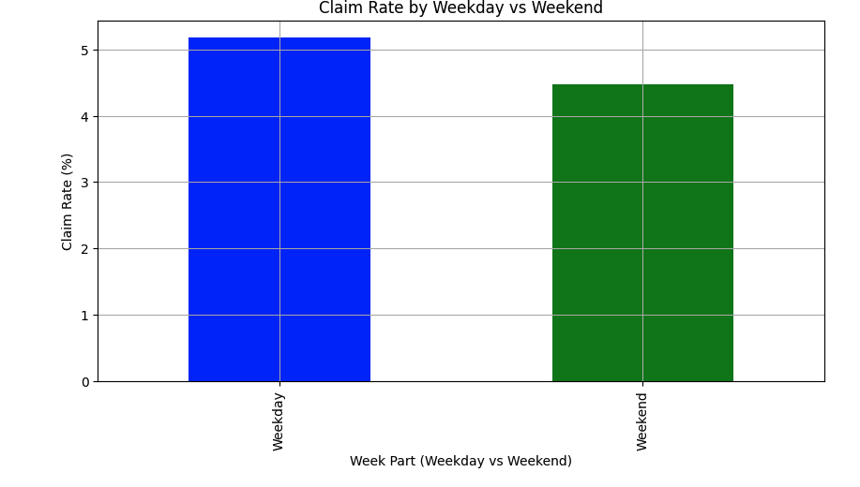
2.5. NCNS (No Call No Show) & Shift Deletion – Prevention of Revenue Leakage.
Findings:
- The market is believed to have lost trust in the concept due to the low shift completion rates.
- NCNS behavior affects facility staffing and results in revenue loss.
Revenue Opportunity:
- Charge facilities a cancellation penalty to cut down on last-minute shift deletions.
- Offer loyalty bonuses for reliability or charge repeat NCNS workers a reinstatement fee.
Recommended Action Plan: Action Plan:
- Facility Shift Cancellation Fee: Fine-tune the facility to charge a 10% penalty for last-minute shift cancellations.
- NCNS Recovery Plan for the Worker: Workers with high NCNS rates undergo extra onboarding training before rehiring.
- Facility Priority Badge: To show appreciation, allow facilities with low shift deletions to prioritize their workers in the workforce.

3. Recommendations and Next Steps for Revenue Optimization
A . Use the Following AI-Powered Dynamic Pay Rate Adjusters
- Do not allow more than $40 per hour for most shifts unless there is a need for higher rates due to demand.
- Instead of increasing the basic pay, give bonus-based incentives.
- Introduce SmartPay Algorithm: This algorithm will help automatically change the pay according to the shift demand.
B . Shift Posting Priority can be monetized for Facilities.
- Make workplaces pay for ‘Prime Shift Posting’ at peak times (10 am).
- Launch a ‘Fast Claim Guarantee’ service charge for a fee, ensuring that shifts are filled in less than 3 hours.
C. Subscribe to Workforce Plans.
- Facilitates guaranteed worker fulfillment to a premium subscription plan for facilities.
- Seasonal pricing plans should include a premium for peak times, such as Q4 for shift plans.
D. Enhancing the Worker Reliability and Minimizing the NCNS Losses.
- Make facilities pay a cancellation penalty to prevent shift deletions.
- Try worker loyalty bonuses for up to 100% attendance rates.

4. Conclusion and Future Growth Strategy
The Clipboard Health marketplace has high engagement, but the revenue can be increased by implementing dynamic pricing, premium features, and retention incentives.
By using the following best practices when integrating AI into your pay practices, offering premium shift posting, and implementing loyalty-based engagement strategies, Clipboard Health can Succeed in attracting and retaining both facilities and workers while ensuring the business's longevity.
- Enhance facility revenue through premium features.
- Shift claim rates can be improved without the need for higher pay increases.
- Build up the trust in the marketplace and decrease the worker’s NCNS rates.

